**AI VIRTUAL MOUSE**

**A Project Report**

***Submitted by:***

**Aastha Sharma (2127945)**

**Abhyuday Pant (2127946)**

**Mehak Sharma (2127978)**

**Pranav Dwivedi (2127983)**

***in partial fulfilment for the award of the degree***

***of***

**BACHERLOR OF TECHNOLOGY**

**IN**

**COMPUTER SCIENCE AND ENGINEERING**

at



**I.K. GUJRAL PUNJAB TECHNICAL UNIVERSITY**

**MOHALI CAMPUS-1**

**APRIL-2024**

## CERTIFICATE

This is to certify that the project titled “**AI VIRTUAL MOUSE**” is the bona fide work carried under my supervision, by **AASTHA SHARMA, ABHYUDAY PANT, MEHAK SHARMA and PRANAV DWIVEDI,** students of B. Tech (CSE) of I.K. GUJRAL PUNJAB TECHNICAL UNIVERSITY, MOHALI CAMPUS-1, Punjab (India), during the academic year 2023-24, in partial fulfilment of the requirements for the award of the degree of Bachelor of Technology (Computer Science and Engineering).

Signature

**Dr. Neeraj Mohan**

**(Project Guide)**

Place**: Mohali, Punjab, India**

Date**: 9th April, 2024**

**Chapter 1: Project Profile**

1.1 Project Definition  
The AI Virtual Mouse project aims to revolutionize computer input methods by introducing a machine learning-powered virtual mouse system. Leveraging deep learning and computer vision technologies, the project offers a hands-free, gesture-based control system for users, addressing limitations of traditional input devices.

1.2 Scope and Objective of Project  
The primary objective of the project is to develop an AI Virtual Mouse system capable of accurately interpreting hand gestures captured by a device's camera and translating them into precise mouse movements and actions on the screen. The scope includes research, development, and testing of the system to ensure its effectiveness and usability across various computing platforms and applications.

**Chapter 2: System Study and Problem Formulation**

2.1 Data Analysis  
Data analysis involves gathering and analysing relevant data regarding hand gestures, computer vision algorithms, and existing virtual mouse systems to inform the design and development of the AI Virtual Mouse.

1. **Hand Gesture Data Collection:**
   * Collecting a diverse dataset of hand gestures captured through video recordings or real-time interactions.
   * Ensuring the dataset includes a variety of hand gestures relevant to mouse control, such as pointing, clicking, dragging, and scrolling.
2. **Computer Vision Algorithms:**
   * Researching and analyzing various computer vision algorithms suitable for hand gesture recognition.
   * Evaluating the performance and accuracy of different algorithms in detecting and interpreting hand gestures from image or video data.
3. **Existing Virtual Mouse Systems:**
   * Reviewing and analyzing existing virtual mouse systems to understand their functionalities, limitations, and performance.
   * Identifying successful approaches and best practices that can be leveraged in the development of the AI Virtual Mouse system.
4. **Data Preprocessing:**
   * Preprocessing the collected hand gesture data, including resizing, normalization, and augmentation.
   * Ensuring the data is clean, properly formatted, and suitable for training machine learning models.
5. **Model Selection and Training:**
   * Selecting appropriate machine learning models, such as convolutional neural networks (CNNs), for hand gesture recognition.
   * Training the selected models on the preprocessed hand gesture data to learn patterns and features indicative of different gestures.
6. **Evaluation and Validation:**
   * Evaluating the trained models' performance using validation datasets and metrics such as accuracy, precision, recall, and F1-score.
   * Iteratively refining the models based on evaluation results to improve their accuracy and generalization ability.
7. **Feature Engineering:**
   * Experimenting with different features and representations of hand gestures, such as key point detection or motion trajectories.
   * Identifying informative features that enhance the models' ability to accurately recognize and interpret hand gestures.
8. **Data Visualization and Interpretation:**
   * Visualizing the analysed data, model outputs, and evaluation metrics to gain insights into the performance and behaviour of the AI Virtual Mouse system.
   * Interpreting the results to identify strengths, weaknesses, and areas for improvement in the system's hand gesture recognition capabilities.

2.2 Proposed System  
The proposed system utilizes deep learning and computer vision technologies to track hand gestures and movements captured by a camera, enabling users to control the mouse cursor through gestures.

2.3 Advantages of Proposed System

* Hands-free operation
* Enhanced accessibility for users with physical disabilities
* Intuitive and natural interaction with computing devices

2.4 Feasibility Study  
The feasibility study assesses the technical, operational, and economic viability of the proposed system.

2.4.1 Technical

* **Compatibility:** The system must be compatible with a wide range of hardware configurations, including various camera devices and computing platforms (e.g., laptops, desktops, tablets).
* **Performance:** The system should be capable of processing hand gestures in real-time with minimal latency, ensuring smooth and responsive interaction.
* **Scalability:** The system should be scalable to accommodate future updates, improvements, and integrations with new technologies.

2.4.2 Operational

* **Usability**: The system is user-friendly and intuitive, requiring minimal training for users to become proficient in using hand gestures for mouse control.
* **Integration**: The system seamlessly integrates with existing operating systems and software applications, allowing users to perform common computing tasks efficiently.
* **Maintenance**: The system is easy to maintain and support, with provisions for updates, troubleshooting, and user support.

2.4.3 Economical

* **Cost-Benefit Analysis:** The system's costs associated with development, deployment, and maintenance are justified by the potential benefits and returns on investment.
* **ROI Calculation:** The expected return on investment (ROI) is estimated based on factors such as increased productivity, reduced hardware costs (e.g., no need for physical mice), and potential market demand for the product.
* **Resource Allocation:** The availability and allocation of resources, including budget, time, personnel, and infrastructure, required for the successful implementation of the system, are assessed.

2.5 System Requirements

**Hardware Requirements:**

* A device with a built-in or external camera capable of capturing video input.
* Adequate processing power to run real-time computer vision algorithms.
* Sufficient memory (RAM) to handle data processing and storage.

**Software Requirements:**

* Operating system compatibility, including Windows, macOS, and Linux distributions.
* Python programming language environment for system development.
* OpenCV library for computer vision functionalities.
* MediaPipe package for hand tracking and gesture recognition.
* Pynput, Autopy, and PyAutoGUI packages for interfacing with the user interface and performing mouse actions.

**User Requirements:**

* Basic familiarity with operating computers and software applications.
* Ability to perform hand gestures in front of a camera.

2.6 Object Oriented Analysis  
Object-oriented analysis involves identifying and modelling the system's entities, attributes, and behaviours using object-oriented principles and methodologies.

**Chapter 3: Project Plan**

3.1 Team Structure  
The project team comprises software engineers, computer vision specialists, and user experience designers responsible for designing, developing, and testing the AI Virtual Mouse system.

3.2 Programming Languages and Development Tools  
Python programming language is used for developing the system, along with OpenCV for computer vision functionalities.

3.3 Object Oriented Design  
Object-oriented design principles are applied to create a modular and extensible system architecture that facilitates flexibility and scalability.

3.4 Reuse of Existing Software Components  
Existing software components, such as libraries and frameworks for hand tracking and gesture recognition, may be leveraged to accelerate development and reduce implementation effort.

**Chapter 4: Structured Analysis and Structured Design**

4.1 Data Flow Diagrams

Level 0 DFD:

* At the center of the diagram, you have a process representing the AI Virtual Mouse system itself.
* One input arrow flows into the process, representing hand gestures captured by the device's camera.
* One output arrow flows out of the process, representing mouse movements/actions on the screen.

Level 1 DFD:

* This level expands on the processes within the AI Virtual Mouse system.
* Inputs include hand gestures captured by the camera and system settings/configurations.
* Processes include:
  1. Hand Gesture Recognition: Analysing input gestures using computer vision algorithms.
  2. Gesture Mapping: Mapping recognized gestures to corresponding mouse movements/actions.
  3. User Interface Interaction: Transmitting mapped gestures to the user interface for controlling the virtual mouse
* Outputs include processed hand gesture data and mouse movements/actions.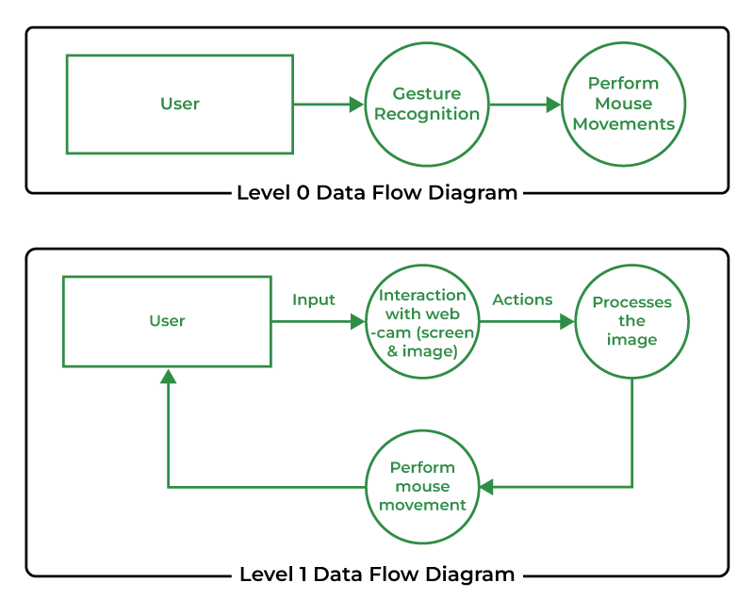
* Flowchart/Algorithm Used  
  Flowcharts and algorithms are developed to describe the logical flow and sequence of operations involved in hand gesture recognition and virtual mouse control.

**Chapter 5: Detailed Design**

5.1 Design Strategy  
The design strategy outlines the approach for organizing system functionality into major modules and sub-modules to facilitate development and maintenance.

5.1.1 Major Modules  
Major modules include components for hand gesture recognition, gesture mapping, and user interface design.

5.1.2 Sub Modules  
Sub-modules further decompose major modules into smaller units of functionality, enhancing modularity and reusability.

5.2 Module Design  
Module design involves specifying the interfaces, dependencies, and interactions between system modules to ensure cohesive and modular system architecture.

5.3 Interface Design  
Interface design focuses on designing intuitive and user-friendly interfaces for controlling the virtual mouse through hand gestures.

**Chapter 6: Testing and Implementation**

6.1 System Testing  
System testing involves validating the functionality, accuracy, and performance of the AI Virtual Mouse system through comprehensive testing procedures.

6.2 Test Plan  
The test plan outlines the approach for conducting functional, performance, and stress tests to evaluate the system's reliability and robustness.

6.2.1 Functional, Performance, and Stress Test  
Functional tests verify the correctness of system functions, performance tests assess system responsiveness and efficiency, and stress tests evaluate system stability under extreme conditions.

6.3 Summary of Results Obtained  
A summary of testing results provides insights into the system's performance, identifying any issues or areas for improvement.

**Chapter 7: Project Legacy**

7.1 Current Status of Project  
The current status of the project is assessed, including progress made, milestones achieved, and remaining tasks.

7.2 Remaining Areas of Concern  
Any remaining technical or managerial concerns are identified, along with proposed strategies for addressing them.

7.3 Technical and Managerial Lessons Learnt  
Lessons learned from the project, both technical and managerial, are documented to inform future projects and improve project management practices.

7.4 Future Recommendations  
Future recommendations outline potential enhancements, extensions, or refinements to the AI Virtual Mouse system to further improve its functionality and usability.

**Bibliography**

Santhosh C. (2023). “Static Hand Gesture Recognition Using Novel Convolutional Neural Network and Support Vector Machine”

S. Shriram et al. (2021). “Deep Learning-Based Real-Time AI Virtual Mouse System Using Computer Vision to Avoid COVID-19 Spread.”

Smith, J. et al. (2019). “Deep Learning Techniques for Hand Gesture Recognition: A Comprehensive Review.”

Johnson, M. (2020). “Gesture-Based Interaction: State of the Art and Future Directions.”

Microsoft Corporation. (2017). “Kinect for Windows SDK Documentation.”